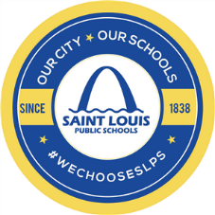St. Louis Public Schools Media Release Form

I understand the photograph(s) or video or audio recording(s) taken of my child by agents, employees or representatives of the Saint Louis Public Schools (hereinafter called “SLPS”) shall be used in connection with the SLPS dissemination of information by its public service and academic programs to the public.

I hereby irrevocably authorize the SLPS to copy, exhibit, publish or distribute any and all such images and audio of my child or wherein he or she shall appear, including composite or artistic forms and media, for purposes of publicizing SLPS programs or for any other lawful purpose. In addition, I waive any right to inspect or approve the finished product, including written copy, wherein my child’s likeness appears.

I hereby hold harmless and release and forever discharge the SLPS from all claims, demands and causes of action, which, my heirs, representatives, executors, administrators or any other persons acting on my or my child’s behalf, may have by reason of this authorization.

Child’s Name Birthdate

I hereby certify that I am the parent or guardian of the minor named above, and do hereby give my consent without reservations to the abovementioned.

Print Parent/Legal Guardian Signature